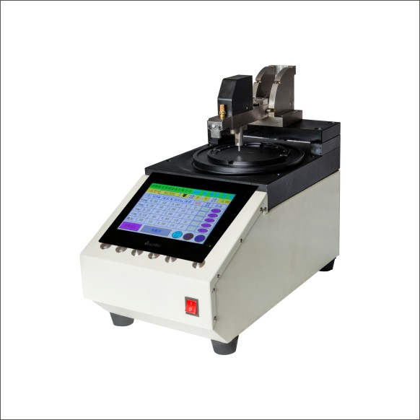RBTX-900M 中心加压光纤研磨机
性能特点 Features
1、配套使用荣邦研磨夹具无需调整设备，去除散件及工艺的影响，干涉可达到100%直通率
2、触屏操作，支持超过12种程序储及调用，更换产品时只需在触屏上选择相应的产品即可，无需繁锁调整压力，时间，转速，简化操作过程及强度，提高质量稳定性
3、可以对调速，压力，时间，缓慢启动 加压，研磨补偿参数及每道的研磨垫等参数进行单独设定，研磨过程中实时显示相关参数的设定值及当前实际值
4、结构更稳定，压力范围更宽，研磨过程中压力基本无任何跳动。可同时研磨18个以上SC而保持设备稳定（100%3D)
5、支持缓慢启动，缓慢加压，研磨补偿研磨时间逐步递增等高级功能选项，有利于保证产品质量，同时减少研磨片损耗
6、主要原器件采用国际知名品牌，主题结构经过3年左右的时间实验，结构寿命及精度保持时间长
7、兼容所有Domaille原装夹具，设备具有更高的精度及稳定性
8、特别适合于MTP(MPO)，MTRJ，E-2000，FA等产品的研磨

1. Without adjusting equipment used RongBang grinding fixture, remove the parts and process, the influence of interference can be rolled yield 100%
2. Touch screen operation, support more than 12 program calls，exchange products only need to select the products on the touch screen,no more complex pressure adjustment，time, speed,simplify operation process and strength，improve the quality stability。
3. To speed,pressure,time,slow start-up pressure,abrasive compensation parameters and each of the parameters such as grinding pad separately setting,real-time display related parameters in the process of grinding set value and the actual value.
4. More stable structure,pressure range is wider,basic close not have any pressure in the process of grinding.Can be grinding at the same time more than 18 SC and maintain stability of the device (3D)100%.
5. Support the slow start,slow pressure,grinding milling time increasing gradually advanced features such as options,to ensure the quality,at the same time reduce the loss of grinding sheet.
6. Main components adopt international famous brand,Thematic structure after 3 years of time to experiment,the structure and accuracy keep long life.
7. Compatible with all Domaille original fixture, equipment has a higher accuracy and stability.
8. Particularly suitable for MTP(MPO)，MTRJ，E-2000，FA products such as grinding.

